1. **Goal**: Retry pattern helps us to make multiple calls when a service is temporarily failed.
2. We have thousands of microservices in our architecture and due to network disruption, some service maybe down for some time. So during that time, we want to retry.
3. 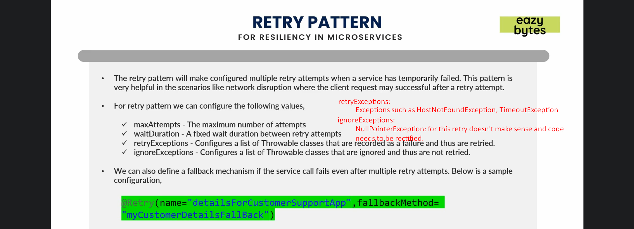
4. With Resilience4j and Spring Boot we can achieve this pattern very easily.